**Student Roster I**

In this assignment, you will practice one-to-one relationships by creating a student roster application. Analyze the wireframe below and create the appropriate domain models with the correct relationships.

Wireframe

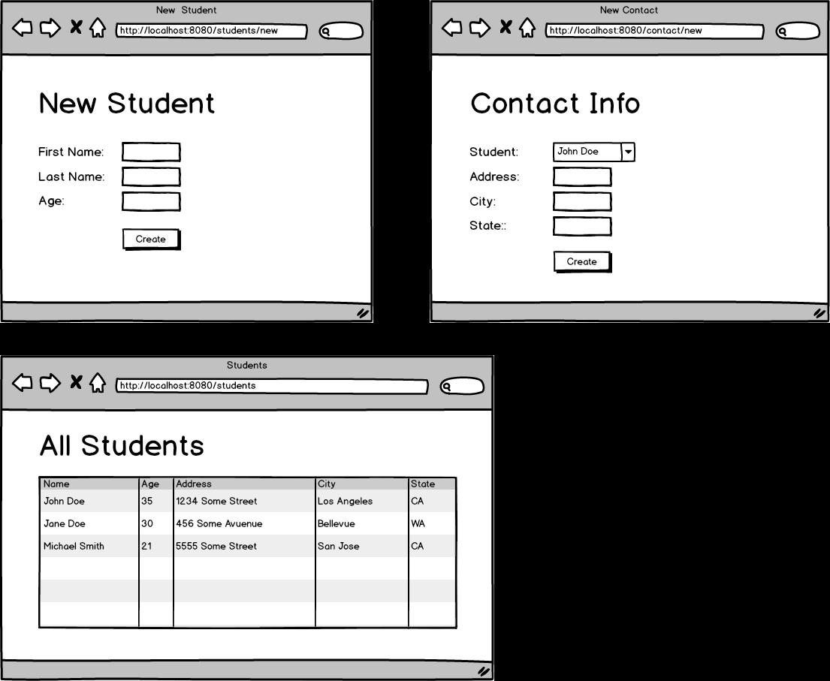

Set Up

Creating the web view for this assignment will be optional (only if you are behind schedule). First, create one controller and one service called ApiService. This service will have all the repository dependencies that you need. Complete each task below.

Tasks:

* Have a method handler in the controller for the following example url: /students/create?firstName=John&lastName=Doe&age=35. Create 4 students with this method.
* Have a method handler in the controller for the following example url: /contacts/create?student=1&address=1234%20Some%20Street&city=Los%20Angeles&state=CA. The student query parameter should be the id of the student in the database. Create the contact info for the students from the previous task. (%20 is the encoding for SPACE in query parameters)
* Have a method handler in the controller for the following example url: /students. Print all the students information along with their contact information in the console.

Optional (Only if behind):

* Create the web view for this assignment.
* Create a web page to create students
* Create a web page to create contacts of existing students
* Create a web page that displays the information of each student.

Topics:

* 1:1 relationships
* JPA methods